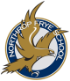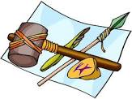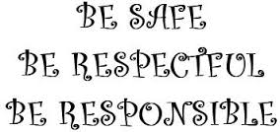

**Language Arts**

**Writing**

We are exploring a unit on procedural writing. Students will have the opportunity to make butter in their classrooms and then write about it using the procedural writing structure. We will be learning about the persuasive writing form .

**Reading**

Grade 2 students across New Brunswick will be participating in a provincial reading assessment. We have been preparing students all year for this assessment through our literacy instruction.

See following page for more details

Our focus in reading this term will be on literal, inferential, and critical questioning (finger, head, heart questions). Finger questions are found in the text. Head questions are answered by using clues from the text and our own thinking. Heart questions are when students are asked “how they feel about something”.

**Math**

In ***Numbers*** we are working on adding numbers to 100. Encourage your child to share the strategies they learn about at school. Ask them to explain their thinking and you will be amazed at what they are able to do. If you have questions about the new math strategies please contact your child`s teacher. Students will be travelling to all the grade 2 classes with their math passports to learn about 3D shapes, graphing, and measurement.

## Curriculum Goals

Anglophone East School District

May &

June 2016

Volume1, Issue 6

Northrop Frye School

Grade 2

Curriculum Newsletter

#### Important Dates

✓ May 6— Professional learning day. (no school for students)

✓ May 10-11—students bring in items for Technology museum

✓ May 12– Technology museum

✓ May 20—NBTA Day (no school for students)

✓ May 23—Victoria Day (no school for students)

✓ May 24-31–Provincial Reading Assessment

✓ May 27—Northrop Frye School Family Fun Night

✓ May 30—Night of the Arts

✓ June 3—Seussical Field Trip and Walk and Roll

✓ June 20—Zoo Field Trip

✓ June 24—Last day of school for students

✓ Field Day TBA

**You & Your World**

We have begun the technology unit in ***Changes.*** Students have been asked to bring in an item to showcase at our grade 2 technology museum. Students will have the opportunity to view and learn about each other’s artifacts while focusing on how they are used to make life better, easier or more interesting.