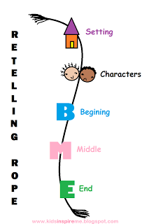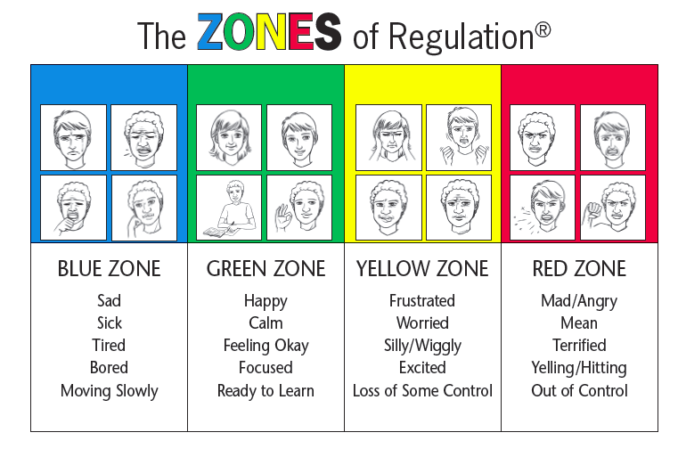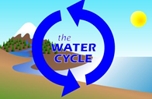

**Take a moment with your child and have him/her explain the zones of regulation chart above and how it helps him/her to be ready for learning.**

**Language Arts**

**Writing**-We will begin a unit on non fiction writing. We will continue to work on the consistent use of proper end punctuation and the correct spelling of “**No Excuse**” words.

**Reading**– Exploring non fiction texts will be a focus in reading this term along with maintaining and improving fluency, comprehension, accuracy, and expanding vocabulary. **Congratulations goes to the many students who have completed their first reading club bingo!**

Retelling Ropes—have your child retell their stories in sequence.

**Math**

In ***Numbers*** we continue to work towards automaticity with sums up to 10. Students are being exposed to facts to 20 and they are using their **known strategies** (counting on, doubles, near doubles, partners to 5,10, and 20, and one more/one less, two more/two less) to begin to tackle these more challenging types of questions. Knowing and explaining the difference between **even and odd** numbers is also being covered this term.

## Curriculum Goals

Anglophone East School District

January & February 2016

Volume1, Issue 4

Northrop Frye School

Grade 2

Curriculum Newsletter

#### Important Dates

#### Jan.

✓ Jan 15.—Crazy hair day $1

✓ Jan. 22—Time warp day $1

✓ Jan. 26—Lunch time Zumba party $1

✓ Jan. 27—Family Literacy Day. Dress as your favourite literary character $1

**You & Your World**

Our next unit in **Changes** will be exploring the

*watercycle*. . .