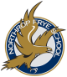

The Holidays are a perfect time to build your child’s story bank. Your traditions and family gatherings provide great stories and story ideas.

Please take the time to talk about the experiences that you have enjoyed

over the holidays. It doesn’t need to be anything big, an afternoon of sliding or a special outing for hot chocolate will give them something to write about in the New Year.

The Grade 2 Team wants to take this time to wish

you and your family a fantastic holiday!

Whatever your beliefs and traditions in this upcoming season may it be a time to relax and enjoy your loved ones.

**Language Arts**

In ***Writing*** we are continuing to work on writing Personal Narratives as well as introducing Descriptive Writing. This term the expectations are increasing for proper end punctuation and the correct spelling of “No Excuse” words.

Being able to make personal connections to the story or information that they are reading is the focus of this months **Reading** Workshops. It is important that your child read with you and have the opportunity to talk about reading daily.

In the strand of **Speaking and Listening** we continue to work on turn-taking in conversation. Please take the time to practice this skill at home and when you are out and about. Listening and responding are both vital parts of your child’s ability to communicate.

**Math**

In ***Numbers*** we continue to practice our sums up to 10. It is important to build accuracy and efficiency with these. As we extend our exploration it is important that your child can talk about the strategies that they used to get a solution and that they hear other strategies as well. Being able to consider and compare differing strategies allows for your child to evaluate the what they are using and to try new approaches that may serve them better.

## Curriculum Goals

## May Your Days Be Merry and Bright!

Anglophone East School District

November & December 2015

Volume1, Issue 3

Northrop Frye School

Grade 2

Curriculum Newsletter

#### Important Dates

#### Dec.

✓ Dec.5—Mistletoe Market at NFS

✓ Dec.9—Grade 2 Turkey Dinner

✓ Dec.11—Toy Drive and Fill the Bus campaign ending

✓ Dec.15—Holiday Concert

✓ Dec.17—PJ Day

✓ Dec.18– Last Day before the Holidays

✓ Jan.5—TUESDAY, First Day Back.

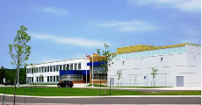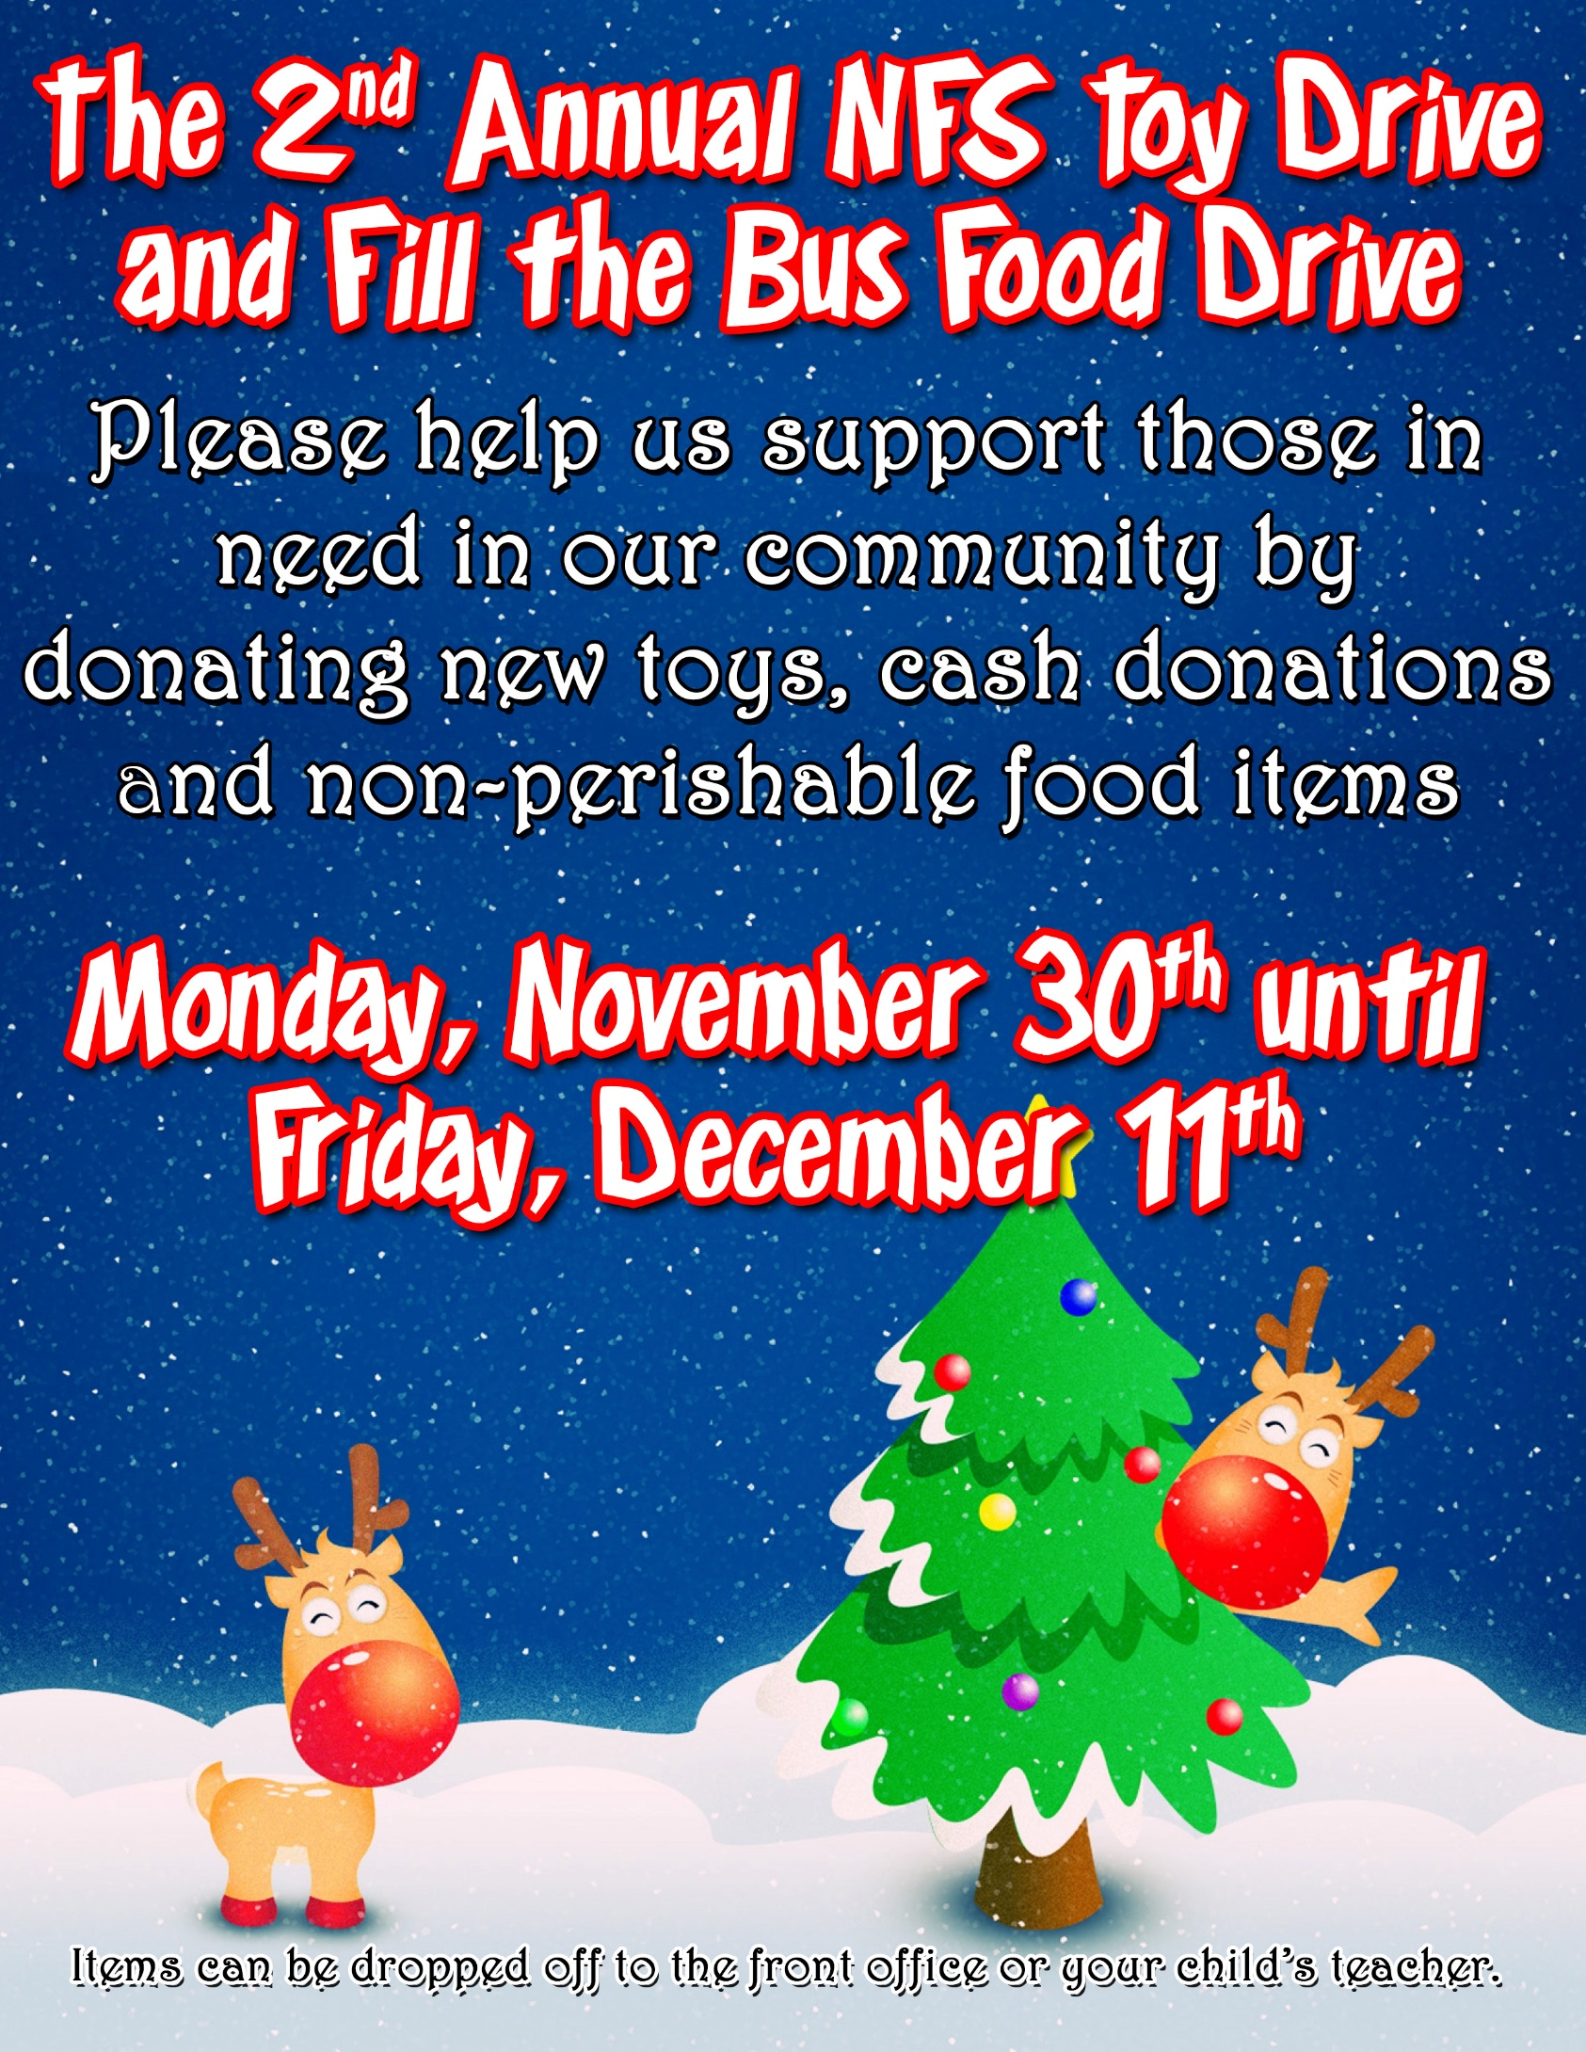

1392 Ryan Street

Moncton NB

E1G 2V3

Northrop Frye School

Please make sure to check our Grade 2 blog and our school website for any important updates.

The District website can be found at...

<http://web1.nbed.nb.ca/sites/ASD-E/Pages/default.aspx>

Here you can find such information as school calendars, bussing information, school closures, etc.

The school website is a good place to find information more unique to our building, like—meeting times, cafeteria ordering, links to the school newsletter, bell schedules and school policies.

<http://web1.nbed.nb.ca/sites/ASD-E/schools/northropfrye/Pages/default.aspx>

If you are looking for information more specific to grade 2 at NFS please check out our Team blog at <https://grade2nfs.weebly.com/>. Here you will be able to find a link to our newsletter, suggested websites and updates on what’s happening in class!

Phone: 506-856-3062

Fax: 506-869-6596

## Stay In Touch

A respectful community of life long learners.

**OUR MISSION**



ASD-E

This would be a good place to insert a short paragraph about your organization. It might include the purpose of the organization, its mission, founding date, and a brief history. You could also include a brief list of the types of products, services, or programs your organization offers, the geographic area covered (for example, western U.S. or European markets), and a profile of the types of customers or members served.

It would also be useful to include a contact name for readers who want more information about the organization.